QUESTION : 1
Import a CSV file of food delivery orders (with columns like order_id, restaurant_name, customer_name, order_amount, order_date) into a new SQL table named FoodOrders using your database tool of choice :

TABLE FoodOrders :
CREATE TABLE FoodOrders(
order_id INT,
restaurant_name VARCHAR(100),
customer_name VARCHAR(100),
order_amount DECIMAL(10,2),
order_date DATE,
PRIMARY KEY(order_id)
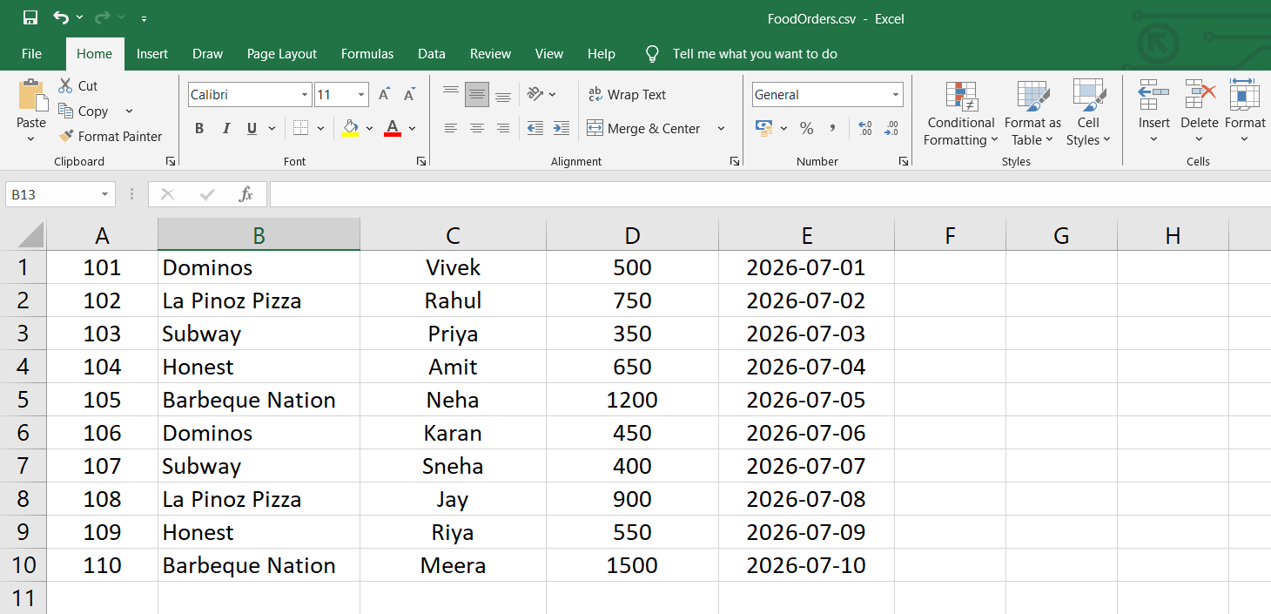
);
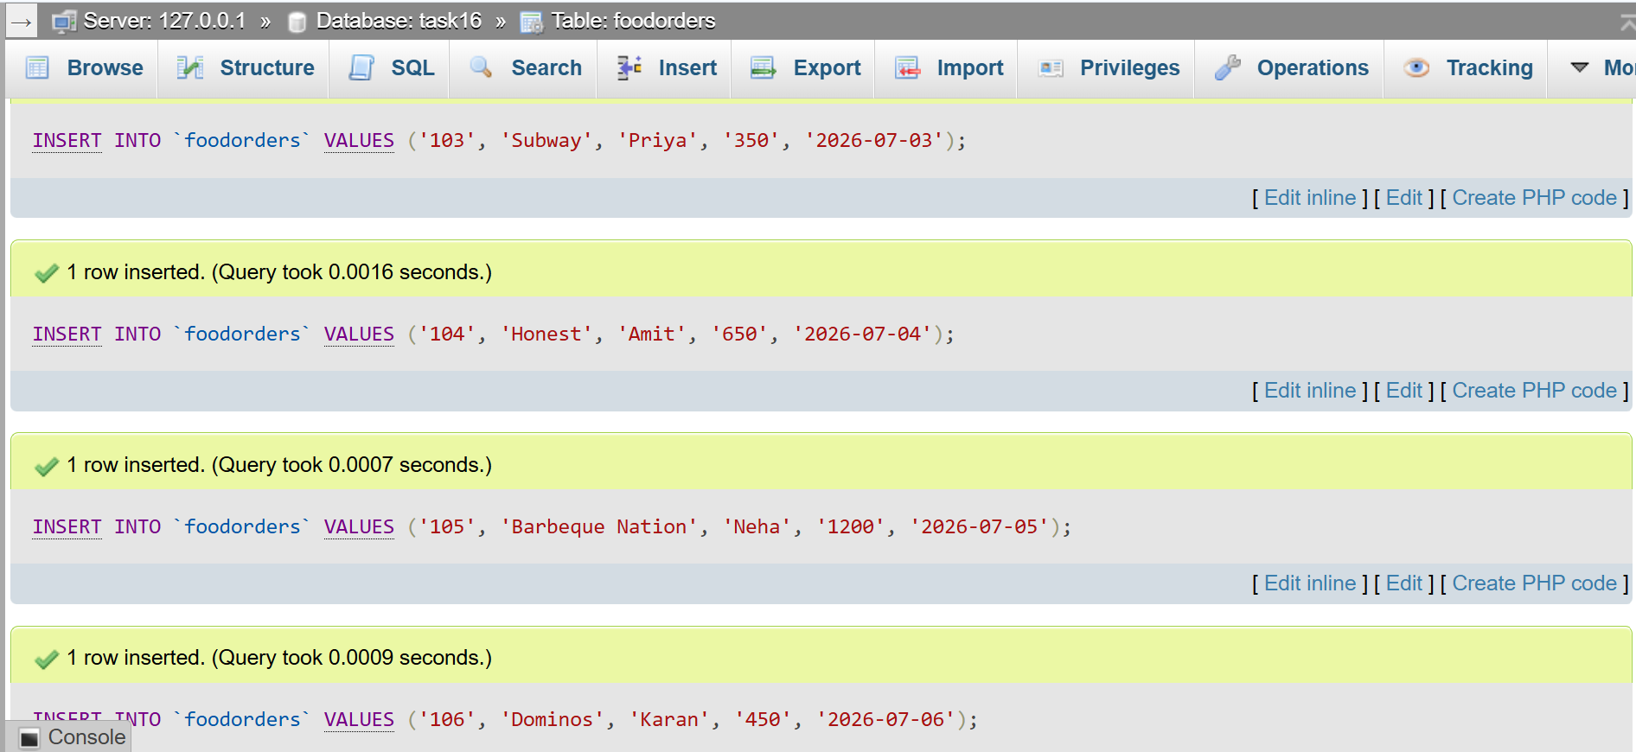
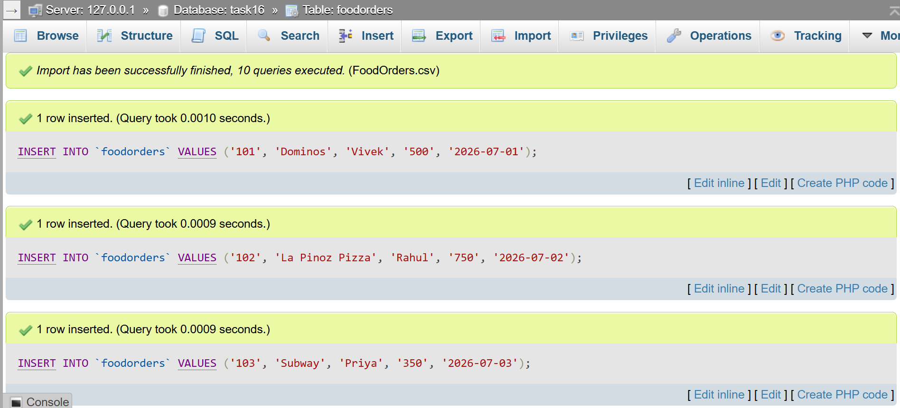
QUESTION : 2
Write SQL statements to create a table called TopSongs with columns: song_id, song_title, artist, streams, and release_date, then insert at least 5 records representing popular tracks from Spotify :
TABLE TopSongs :
CREATE TABLE TopSongs(
song_id INT,
song_title VARCHAR(100),
artist VARCHAR(100),
streams BIGINT,
release_date DATE,
PRIMARY KEY(song_id)
) ;
INSERT INTO TopSongs(song_id,song_title,artist,streams,release_date)
VALUES
(1,'Blinding Lights','The Weeknd',4500000000,'2019-11-29'),
(2,'Shape of You','Ed Sheeran',4200000000,'2017-01-06'),
(3,'As It Was','Harry Styles',3100000000,'2022-04-01'),
(4,'Flowers','Miley Cyrus',2500000000,'2023-01-13'),
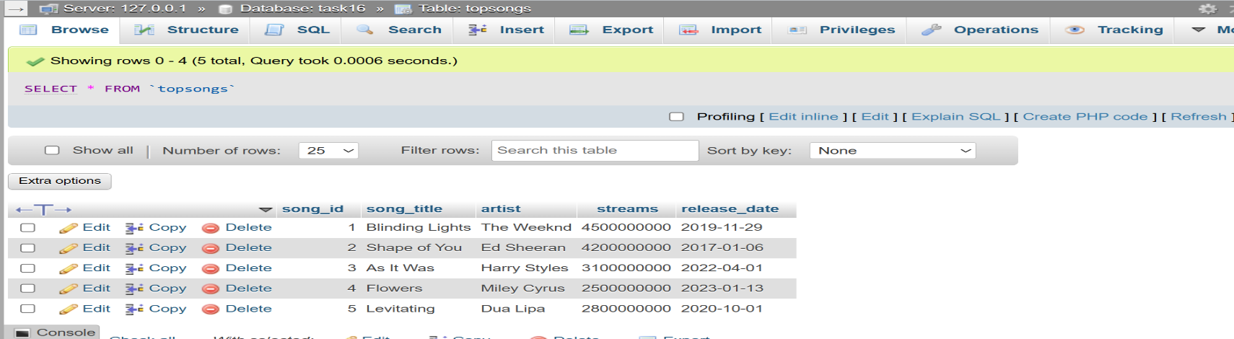
(5,'Levitating','Dua Lipa',2800000000,'2020-10-01') ;
QUESTION : 3
Write an SQL query to find the top 3 customers who ordered the most from the FoodOrders table based on total order_amount, and display their names and total spent :

SELECT customer_name,SUM(order_amount) AS total_spent
FROM foodorders
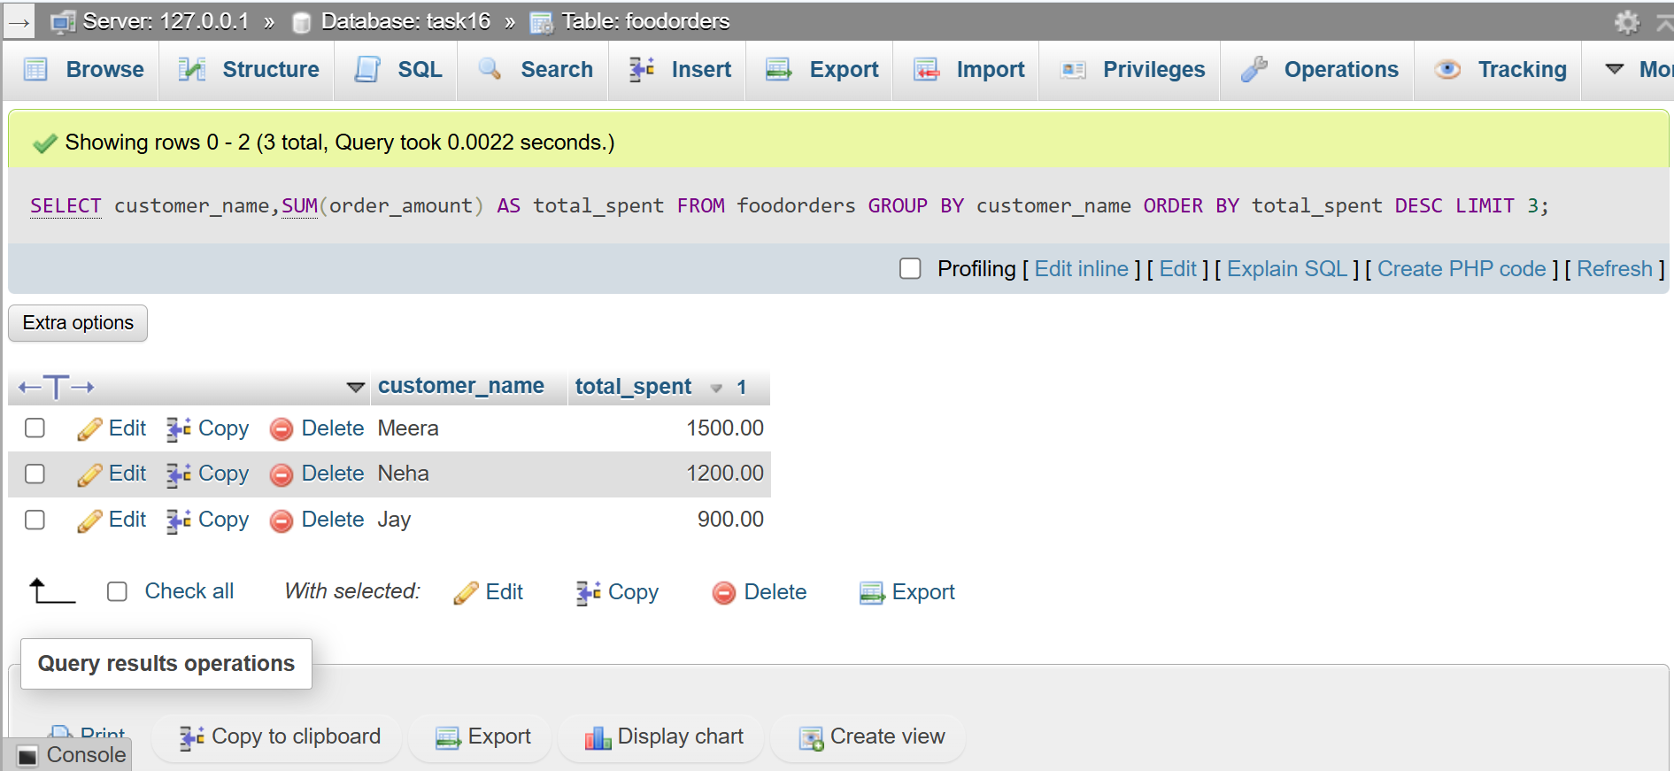
GROUP BY customer_name ORDER BY total_spent DESC LIMIT 3;

QUESTION : 4
Generate a product performance report by writing an SQL query that lists each restaurant_name from FoodOrders, the number of orders, and the total order_amount, ordered by total order_amount descending.<br><br><em><strong>Hint:</strong> Use GROUP BY and ORDER BY clauses.</em> :

SELECT restaurant_name,COUNT(order_id) AS total_orders,
SUM(order_amount) AS total_order_amount
FROM foodorders
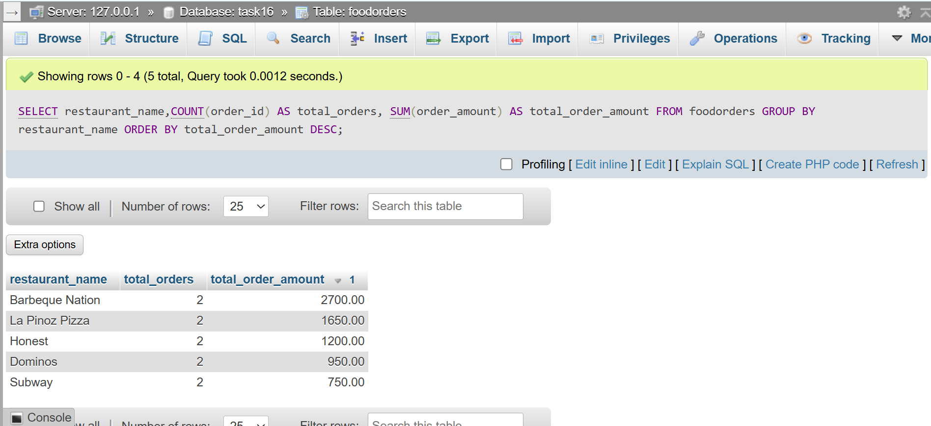
GROUP BY restaurant_name ORDER BY total_order_amount DESC ;

QUESTION : 5
Create an SQL query that calculates two KPIs for the FoodOrders table: (1) average order_amount and (2) total number of unique customers, and format the output for dashboard display (two columns: kpi_name, kpi_value) :

SELECT 'Average Order Amount' AS kpi_name,
AVG(order_amount) AS kpi_value FROM foodorders
UNION
SELECT 'Total Unique Customers' AS kpi_name,
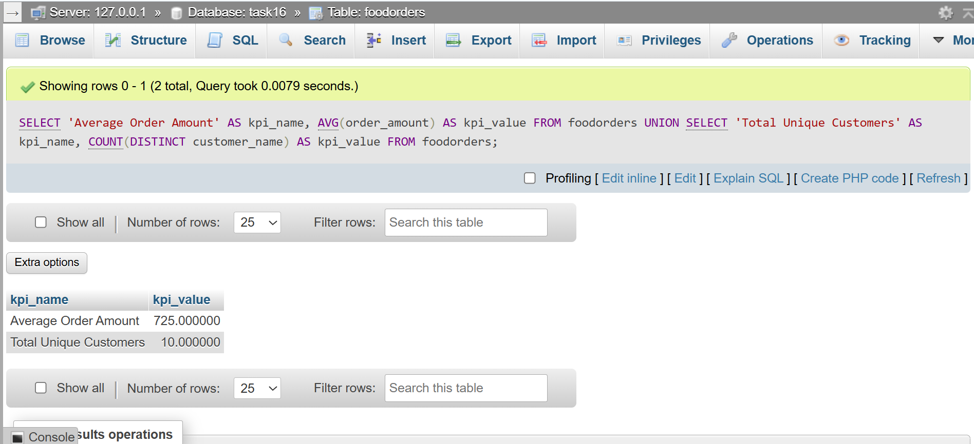
COUNT(DISTINCT customer_name) AS kpi_value FROM foodorders;

